# C2- S2-PRACTICE

*NOTE: check your* ***THEORY slides*** *to answer those questions!*

# **EXERCISE 1**

**Q1)** write a statement to create a database named “school”

To create a database name school: create database school;

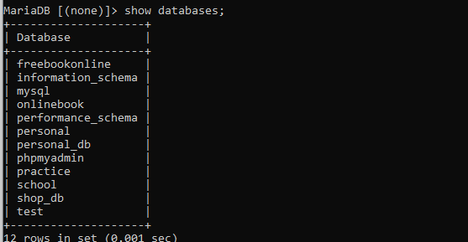

**Q2)** write a statement to drop a database named “school”

To create a database name school: drop database school;

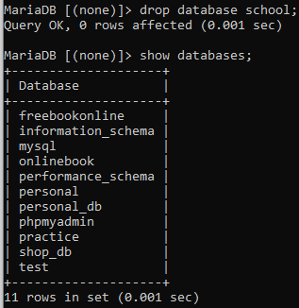

# **EXERCISE 2 – Stock database**

**Q1)** Write a statement to create a database called “stock”.



**Q2)** Write a statement to check if the database “stock” is stored in your MySQL server.

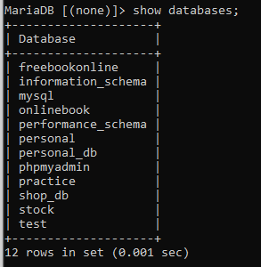

**Q3)** Write a statement to tell MySQL that you are now working on the database named “stock”.

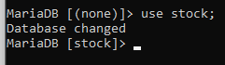

**Q4)** Write a statement to create a table called “category” that has the following structure and check that it has the same structure with the statement:

**DESCRIBE category;**

or

**DESC category;**

+-------------+--------------+------+-----+---------+-------+

| Field | Type | Null | Key | Default | Extra |

+-------------+--------------+------+-----+---------+-------+

| catid | int | NO | PK | NULL | |

| catname | varchar(50) | NO | | NULL | |

| description | varchar(220) | YES | | NULL | |

| mastercatid | int | YES | | NULL | |

+-------------+--------------+------+-----+---------+-------+

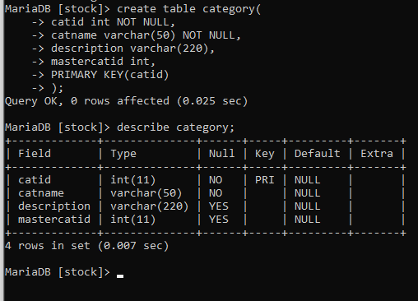

**Q5)** Write a statement to create a table called “supplier” that has the following structure:

+--------------+-------------+------+-----+---------+-------+

| Field | Type | Null | Key | Default | Extra |

+--------------+-------------+------+-----+---------+-------+

| supplierid | int | NO | PK | NULL | |

| suppliername | varchar(40) | NO | | NULL | |

| phone | varchar(12) | YES | | NULL | |

| email | varchar(40) | YES | | NULL | |

| logo | longblob | YES | | NULL | |

| isdeleted | int | YES | | 0 | |

+--------------+-------------+------+-----+---------+-------+

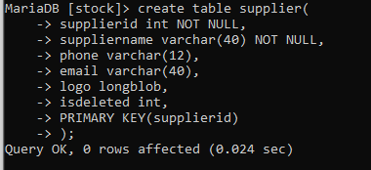

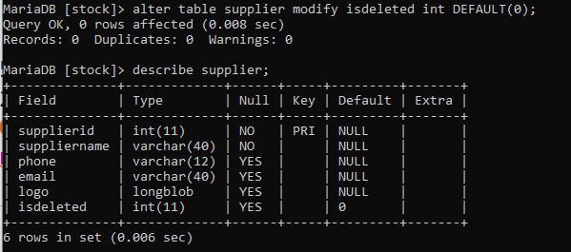

**Q6)** Write a statement to create a table called “masterproductlist” that has the following structure:

+-------------+--------------+------+-----+---------+-------+

| Field | Type | Null | Key | Default | Extra |

+-------------+--------------+------+-----+---------+-------+

| productid | int | NO | PK | NULL | |

| productname | varchar(120) | NO | | NULL | |

| barcode | varchar(40) | YES | | NULL | |

| model | varchar(40) | YES | | NULL | |

| size | varchar(40) | YES | | NULL | |

| unitfactor | varchar(30) | YES | | NULL | |

| catid | int | YES | | NULL | |

| storeid | int | YES | | NULL | |

| isdelete | int | NO | | 0 | |

| description | varchar(220) | YES | | NULL | |

+-------------+--------------+------+-----+---------+-------+

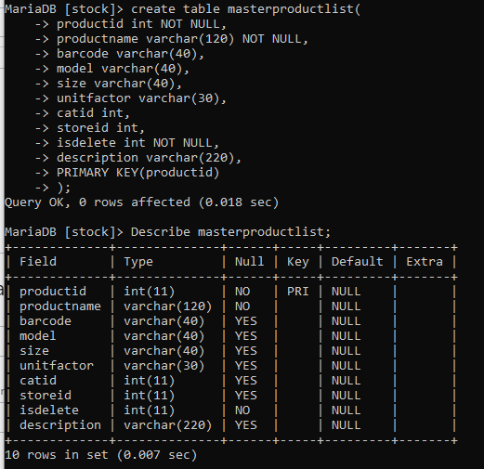

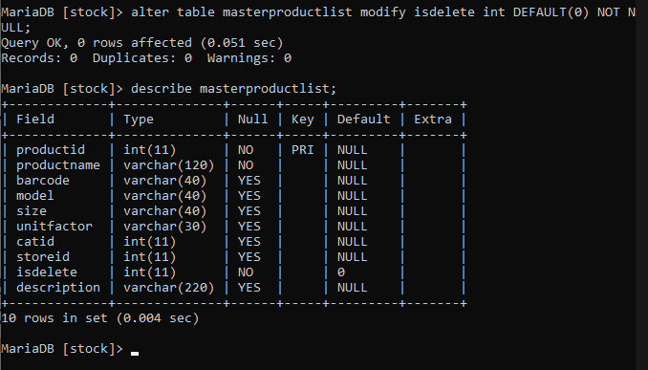

**Q7)** Write a statement to create a table called “store” that has the following structure:

+-------------+--------------+------+-----+---------+-------+

| Field | Type | Null | Key | Default | Extra |

+-------------+--------------+------+-----+---------+-------+

| storeid | int | NO | PK | NULL | |

| storename | varchar(40) | NO | | NULL | |

| description | varchar(220) | YES | | NULL | |

| locationid | int | YES | | NULL | |

| managerid | int | YES | | NULL | |

| isdeleted | int | NO | | 0 | |

+-------------+--------------+------+-----+---------+-------+

*Check slides*

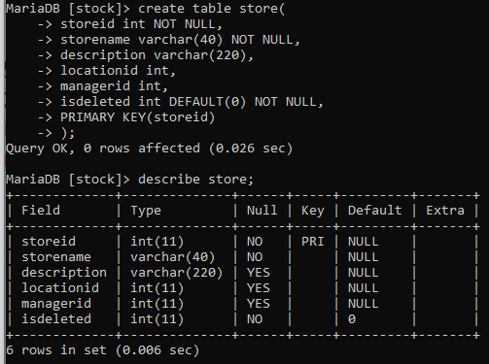

**Q8)** Write a statement to create a table called “location” that has the following structures:

+--------------+--------------+------+-----+---------+-------+

| Field | Type | Null | Key | Default | Extra |

+--------------+--------------+------+-----+---------+-------+

| locationid | int | NO | PK | NULL | |

| locationname | varchar(50) | NO | | NULL | |

| description | varchar(200) | YES | | NULL | |

| managerid | varchar(20) | YES | | NULL | |

+--------------+--------------+------+-----+---------+-------+

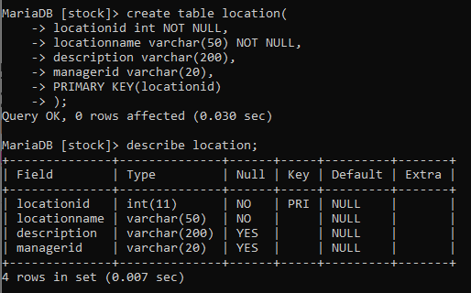

**Q9)** Write a statement to add a new column called “isdeleted” to be type of integer after column “mastercatid” in table “category” by setting the default value to 0.

*Check slides*

+-------------+--------------+------+-----+---------+-------+

| Field | Type | Null | Key | Default | Extra |

+-------------+--------------+------+-----+---------+-------+

| catid | int | NO | PK | NULL | |

| catname | varchar(50) | NO | | NULL | |

| description | varchar(220) | YES | | NULL | |

| mastercatid | int | YES | | NULL | |

| isdeleted | int | YES | | 0 | |

+-------------+--------------+------+-----+---------+-------+

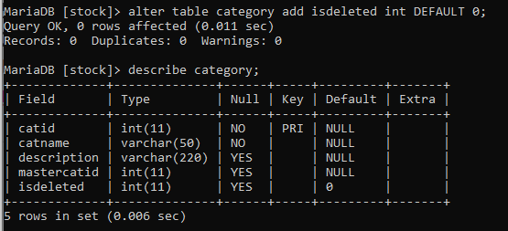

**Q10)** Write a statement to remove a column called “managerid” from table “location”.

*Check slides*

+--------------+--------------+------+-----+---------+-------+

| Field | Type | Null | Key | Default | Extra |

+--------------+--------------+------+-----+---------+-------+

| locationid | int | NO | PK | NULL | |

| locationname | varchar(50) | NO | | NULL | |

| description | varchar(200) | YES | | NULL | |

~~| managerid | varchar(20) | YES | | NULL | |~~

+--------------+--------------+------+-----+---------+-------+

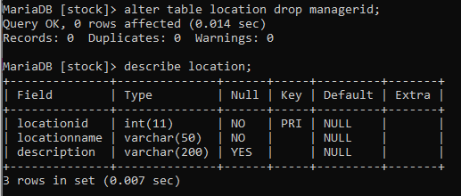

**Q11)** Write a statement to rename column “logo” to “companylogo” in table “supplier”

*Check slides*

+--------------+-------------+------+-----+---------+-------+

| Field | Type | Null | Key | Default | Extra |

+--------------+-------------+------+-----+---------+-------+

| supplierid | int | NO | PK | NULL | |

| suppliername | varchar(40) | NO | | NULL | |

| phone | varchar(12) | YES | | NULL | |

| email | varchar(40) | YES | | NULL | |

| companylogo | longblob | YES | | NULL | |

| isdeleted | int | YES | | 0 | |

+--------------+-------------+------+-----+---------+-------+

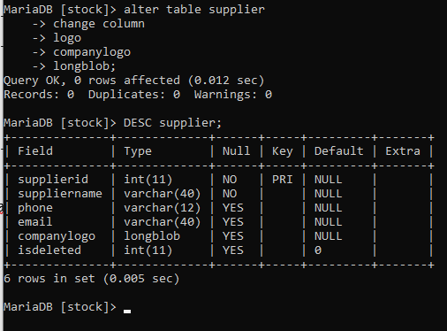

**Q12)** Write a statement to rename table “masterproductlist” to table “productlist”.

*Check slides*

+-----------------+

| Tables_in_stock |

+-----------------+

| category |

| location |

| productlist |

| store |

| supplier |

+-----------------+

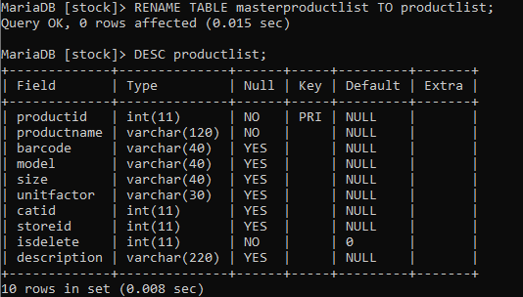

**Q13)** Write a statement to create a new table called “product” that has the same structure as table “productlist” by using the LIKE statement.

CREATE TABLE IF NOT EXISTS <newTable> LIKE <oldTable>;

+-------------+--------------+------+-----+---------+-------+

| Field | Type | Null | Key | Default | Extra |

+-------------+--------------+------+-----+---------+-------+

| productid | int | NO | PK | NULL | |

| productname | varchar(120) | NO | | NULL | |

| barcode | varchar(40) | YES | | NULL | |

| model | varchar(40) | YES | | NULL | |

| size | varchar(40) | YES | | NULL | |

| unitfactor | varchar(30) | YES | | NULL | |

| catid | int | YES | | NULL | |

| storeid | int | YES | | NULL | |

| isdelete | int | NO | | 0 | |

| description | varchar(220) | YES | | NULL | |

+-------------+--------------+------+-----+---------+-------+

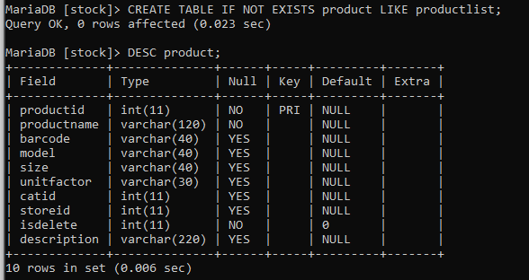

**Q14)** Write a statement to create a table called “positionlist” that has the following structures:

+--------------+--------------+------+-----+---------+-------+

| Field | Type | Null | Key | Default | Extra |

+--------------+--------------+------+-----+---------+-------+

| positionid | int | NO | PK | NULL | |

| positionname | varchar(50) | NO | | NULL | |

| description | varchar(200) | YES | | NULL | |

+--------------+--------------+------+-----+---------+-------+

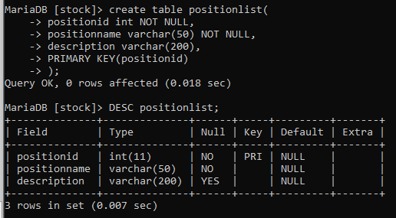

**Q15)** Write a statement to create a table called “department” that has the following structures:

+-------------+--------------+------+-----+---------+-------+

| Field | Type | Null | Key | Default | Extra |

+-------------+--------------+------+-----+---------+-------+

| depid | int | NO | PK | NULL | |

| depname | varchar(40) | NO | | NULL | |

| description | varchar(200) | YES | | NULL | |

+-------------+--------------+------+-----+---------+-------+

